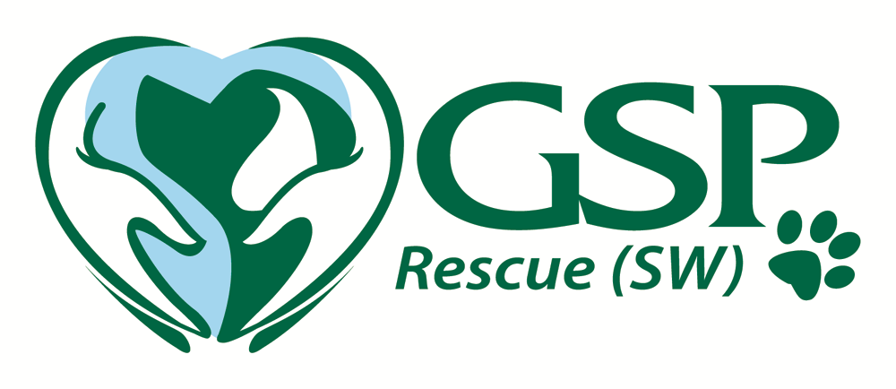
ADOPTION AGREEMENT
This agreement is made on ........................., 201 between: (your name & address)

and GSP RESCUE (SW) of 18, York Road, Brookenby, Lincs LN8 6EX
Your Telephone number(s) [..................................................................................] (the “Adopter”).
Adoption of [Name and description of dog]

The Adopter has agreed to adopt the above mentioned dog according to the terms of this agreement:-
GSP Rescue (SW) will remain the owner of this dog in any event, and the Adopter may not transfer or assign any of his/her rights in the dog adopted under this agreement.
GSP Rescue (SW) may terminate this agreement and repossess the dog as described above at any time if it believes that this dog has been maltreated or neglected in any way, or if the Adopter breaches this agreement. If the Adopter is unable or unwilling at any time to continue the adoption, he/she will notify GSP Rescue (SW) and promptly return this dog to GSP Rescue (SW) by arrangement.
Adopter’s responsibilities
The Adopting person will be responsible for the care of this GSP from the date of this agreement. This includes responsibility for arranging and paying for any veterinary treatment (including recommended inoculations) which this dog may require.
The adopting person also agrees that should the dog or bitch be ‘entire’, that they will take the responsibility to have him or her neutered or spayed at the earliest appropriate time* at their own cost, (at least within 6 months of taking the GSP from Rescue SW), and prove to GSP Rescue (SW) that this has been completed with a note of verification from the vet. * Three months after a season for a bitch, and within 3 months for a dog once that dog is 18 months old.
The Adopter will promptly notify GSP Rescue (SW) if his/her contact address or telephone number provided above changes.
The Adopting party may not use this dog in any breeding programme whatsoever.
The Adopting party will allow a representative of GSP Rescue (SW) to visit this GSP at any time on reasonable notice to check this dog’s welfare and well-being.
The Adopting party confirms that he/she is responsible for this dog from the date of this agreement and acknowledges that GSP Rescue (SW) has disclosed to the Adopter all relevant information which it has been given about this dog.
Note: That will include all information provided by the previous owner (where relevant), plus anything which GSP Rescue (SW) has observed about this dog.
The Adopting party understands that they should be aware that basic rules apply when taking on an adopted dog – e.g. don’t let this dog off the lead for at least a couple of weeks or until you have established a command structure that the dog understands; also do NOT leave this dog unsupervised around small children/small animals until you yourself are confident of their welfare.
The Adopting party agrees that at no time can GSP Rescue (SW) be held responsible for any damage or injury caused by this dog, except for death or serious injury caused by the negligence of GSP Rescue (SW).
The Adopting party indemnifies GSP Rescue (SW) against any costs, claims or liability arising as a result of the adoption of the GSP mentioned above upon signing this agreement.
GSP Rescue (SW) confirms that if a qualified veterinary surgeon advises treatment for this dog, or that the dog must be put down to prevent further suffering in the case of severe illness or injury, the Adopter may give any necessary permissions to the veterinary surgeon on behalf of GSP Rescue (SW).
!/We agree to the terms and conditions outlined above by GSP Rescue (SW) relating to the adoption of the dog ‘ ‘ (dogs name).
.........................................................Adopter’s Name
…………….................................... Adopter’s Signature
Dated .....................................
We also request an Adoption fee to help in the continued running and support of the rescue, which will have been advised to you prior to you taking the dog. Please make cheques payable to ‘GSP Rescue (SW), or preferably use the ‘Donate’ link on the main website to use PayPal.
Please complete and return this form (together with the Adoption fee) within 3 days of the adoption taking place to:
GSP Rescue (SW), October House, 18 York Road, Brookenby, Lincs LN8-6EX
Thank you
Sarah Hadley
on behalf of GSP Rescue (SW)
www.gsprescuesw.co.uk
01472 398653 (no calls after 9.00 pm please)

